CTM-I Use Case

Firm Statistics

Version 0.1

Use Case Name | Firm Statistics
Actor | CBOE Firm, Market Ops, Operations, App Support
Q | User has Browser and is aware of the http path to the application.  User has successfully logged into the CTM-I application.  User has the right role to see the menu options.
Post Conditions | None
Screenshot | 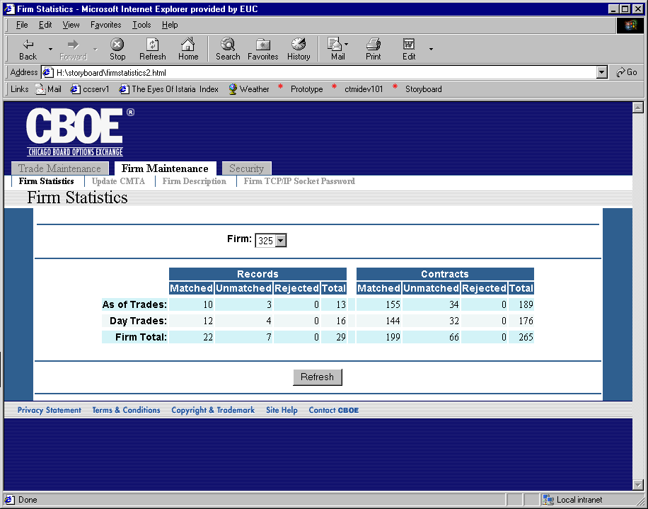
Flow of Events | - User selects “Firm Statistics” from the menu.  - Firm Statistics screen appears  - User can enter data in the following fields  - Firm  - The list of firms is limited by security  - Users with permissions to select any firm have all firms  - Users with limited firms can select firms they are authorized to see.  - The Firm Statistics for the user authorized firms will be requested from CTM-R  - Refresh button will retrieve the most current data for the firm by asking CTM-R for new data.
Alternative Path | - When the firm is changed in the firm selection, the screen will immediately send a request to CTM-R to get the data for the selected firm.

